PROGRAM – 1
Implement the data link layer framing methods such as character, character stuffing and bit stuffing.
Character stuffing :
#include <stdio.h> #include <string.h> void main() { char frame[50][50], str[50][50]; char flag[] = "flag"; char esc[] = "esc"; int i, j, k = 0, n; strcpy(frame[k++], "flag"); printf("Enter the number of Strings: "); scanf("%d", &n); getchar(); // To consume the newline character left by scanf printf("Enter Strings:\n"); for (i = 0; i < n; i++) { fgets(str[i], sizeof(str[i]), stdin); str[i][strcspn(str[i], "\n")] = '\0'; // Remove newline character
}
printf("\nYou entered:\n"); for (i = 0; i < n; i++) { puts(str[i]);
} for (i = 0; i < n; i++) { if (strcmp(str[i], flag) != 0 && strcmp(str[i], esc) != 0) { strcpy(frame[k++], str[i]);
} else { strcpy(frame[k++], "esc"); strcpy(frame[k++], str[i]);
}
}
strcpy(frame[k++], "flag"); printf("-----------------------\n"); printf("Byte stuffing at sender side:\n"); printf("-----------------------\n"); for (i = 0; i < k; i++) { printf("%s\t", frame[i]);
} printf("\n");
}
Output:
Enter no.of String: 4 Enter String jnuth esc flag
Cem
You entered : jnuth esc flag
Cem
------------------------------- Byte stuffing at sender side:
-------------------------------
Flag jnuth esc esc esc flag cem flag

BIT STUFFING :

#include <stdio.h> int main() { int n, i, j, count = 0; printf("Enter the size of data: "); scanf("%d", &n); int a[n], b[20]; printf("Enter the data bits: "); for (i = 0; i < n; i++) { scanf("%d", &a[i]);
} printf("The actual data bits: "); for (i = 0; i < n; i++) { printf("%d", a[i]);
} printf("\n"); // Bit stuffing logic for (i = 0, j = 0; i < n; i++) { b[j] = a[i]; j++; if (a[i] == 1) { count++;
if (count == 5) { b[j] = 0; // Insert a 0 after five consecutive 1s j++; count = 0; // Reset the count
}
} else { count = 0; // Reset count if a 0 is encountered
} } printf("After bit stuffing: "); for (i = 0; i < j; i++) { printf("%d", b[i]);
} printf("\n"); return 0;
}
OUTPUT :
Enter the size of data : 7
Enter the data bits : 1
1
1
1
1
1
1
The actual data bits : 1111111
After bit stuffing : 11111011

CHARACTER COUNT :
#include <stdio.h>
#include <string.h>

char data[20][20]; // Array to store frames int n; // Number of frames

void main() { int i, j, ch; // Loop and control variables char inter[20][20]; // Array to store intermediate frames with length prefix

printf("Enter the number of frames: "); scanf("%d", &n);

// Input frames for (i = 1; i <= n; i++) { printf("Frame %d: ", i); scanf("%s", data[i]);
}
// Add character count at the sender for (i = 1; i <= n; i++) { inter[i][0] = '0' + strlen(data[i]); // Store character count as the first character inter[i][1] = '\0'; // Initialize to prevent garbage strcat(inter[i], data[i]); // Append frame data to the count
}
// Display frames at sender printf("\n**** AT THE SENDER ****\n"); printf("Data as frames:\n"); for (i = 1; i <= n; i++) { printf("Frame %d: %s\n", i, inter[i]);
}
// Transmitted data printf("Data transmitted: "); for (i = 1; i <= n; i++) { printf("%s", inter[i]);
} printf("\n");

// At the receiver
printf("\n**** AT THE RECEIVER ****\n"); printf("The data received:\n");

for (i = 1; i <= n; i++) { ch = inter[i][0] - '0'; // Extract character count from the first character for (j = 0; j < ch; j++) { data[i][j] = inter[i][j + 1]; // Copy frame data excluding the length character
}
data[i][ch] = '\0'; // Null-terminate the string
}
// Display received data printf("\nThe data after removing character count is:\n"); for (i = 1; i <= n; i++) { printf("%s", data[i]);
}

// Display data as frames printf("\nThe data in the form of frames:\n"); for (i = 1; i <= n; i++) { printf("Frame %d: %s\n", i, data[i]);
}
}

OUTPUT :
Enter the number of frames:5 frame1:JNTUH frame2:COLLEGE frame3:OF frame4:ENG, frame5:MANTHANI ***AT THE SENDER:***
Data as frames:
Frame1:6JNTUH
Frame2:8COLLEGE
Frame3:3OF
Frame4:5ENG,
Frame5:9MANTHANI
Data transmitted:
6JNTUH8COLLEGE30F5ENG,9MANTHANI
***AT THE
RECEIVER***
The data received:
The data after removing character count
is:JNTUHCOLLEGEOFENG,MANTHANI The data in the form of frames:
Frame1:JNTUH
Frame2:COLLEGE
Frame3:OF
Frame4:ENG,
Frame5:MANTHANI

PROGRAM 2 :
Write a program to compute CRC code for the polynomials CRC12, CRC-16 and CRC CCIP.
#include <stdio.h> #include <string.h> void main() {
int i, j, m, n;
char input[100], key[30], temp[30], quot[100], rem[30], data[100];
// Sender's Side printf("Enter the no. of bits in original data: "); scanf("%d", &m); printf("Enter Data: \n"); for (i = 0; i < m; i++) { scanf(" %c", &input[i]);
} input[m] = '\0'; printf("Enter the no. of bits in divisor: "); scanf("%d", &n); printf("Enter the divisor: \n"); for (i = 0; i < n; i++) { scanf(" %c", &key[i]);
} key[n] = '\0';
// Append n-1 zeros to the input for (i = 0; i < n - 1; i++) { input[m + i] = '0';
} input[m + n - 1] = '\0';
// Copy the first n bits of the input to temp for (i = 0; i < n; i++) { temp[i] = input[i];
}
// Perform division at sender's side for (i = 0; i < m; i++) { quot[i] = temp[0]; if (quot[i] == '1') { for (j = 0; j < n; j++) { temp[j] = (temp[j] == key[j]) ? '0' : '1';
} } for (j = 0; j < n - 1; j++) { temp[j] = temp[j + 1];
}
temp[n - 1] = input[i + n];
}
// Compute remainder for (i = 0; i < n - 1; i++) { rem[i] = temp[i];
} rem[n - 1] = '\0'; // Create the final data to be transmitted for (i = 0; i < m; i++) { data[i] = input[i];
} for (i = 0; i < n - 1; i++) { data[m + i] = rem[i];
} data[m + n - 1] = '\0'; // Display sender's side output printf("\n**** Sender side ****\n"); printf("Quotient is "); for (i = 0; i < m; i++) { printf("%c", quot[i]);
}
printf("\nRemainder is "); for (i = 0; i < n - 1; i++) { printf("%c", rem[i]);
}
printf("\nFinal data after adding remainder is: "); for (i = 0; i < m + n - 1; i++) { printf("%c", data[i]);
}
// Receiver's Side printf("\n\n**** Checking at Receiver's side ****\n"); for (i = 0; i < n; i++) { temp[i] = data[i];
} for (i = 0; i < m; i++) { quot[i] = temp[0];
if (quot[i] == '1') { for (j = 0; j < n; j++) { temp[j] = (temp[j] == key[j]) ? '0' : '1';
} } for (j = 0; j < n - 1; j++) { temp[j] = temp[j + 1];
}
temp[n - 1] = data[i + n];
}
// Compute remainder at receiver's side for (i = 0; i < n - 1; i++) { rem[i] = temp[i];
} rem[n - 1] = '\0'; // Display receiver's side output printf("\nQuotient is "); for (i = 0; i < m; i++) { printf("%c", quot[i]);
}
printf("\nRemainder is "); for (i = 0; i < n - 1; i++) { printf("%c", rem[i]);
} printf("\nFinal data at receiver's end is: "); for (i = 0; i < m + n - 1; i++) { printf("%c", data[i]);
} printf("\n"); }

OUTPUT :
Enter the number of bits in original data: 5
Enter Data: 1 0 1 0 1
Enter the number of bits in divisor: 5
Enter the divisor: 1 0 1 1 1
**** Sender Side ****
Quotient is 11001
Remainder is 10
Final data after adding remainder is:
1010110

Checking at receiver's side
Quotient is 11001
Remainder is 00
Final data at receiver's end is:
1010100

PROGRAM 3 :
Develop a simple data link layer that performs the flow control using the sliding window protocol, and loss recovery using the GoBack-N mechanism.

#include <stdio.h> int main() { int n, s = 0, ack, i; // Get window size printf("Enter window size\n"); scanf("%d", &n); // Start transmitting frames while (s < n) {
// Send frames starting from the unacknowledged frame
for (i = s; i < n; i++) { printf("Frame %d has been transmitted.\n", i);
}
// Wait for acknowledgment printf("\nPlease enter the last Acknowledgment received: "); scanf("%d", &ack);
// Remove acknowledged frames (i.e., shift s to ack + 1) if (ack >= s) { s = ack; // Update the starting frame for the next iteration
} } return 0;
}

OUTPUT :
Frame 0 has been transmitted.
Frame 1 has been transmitted.
Frame 2 has been transmitted.
Frame 3 has been transmitted.
Frame 4 has been transmitted.

Please enter the last Acknowledgment received: 1 Frame 1 has been transmitted.
Frame 2 has been transmitted.
Frame 3 has been transmitted.
Frame 4 has been transmitted.

Please enter the last Acknowledgment received: 3

Frame 3 has been transmitted.
Frame 4 has been transmitted.

Please enter the last Acknowledgment received: 4 Frame 4 has been transmitted.
Please enter the last Acknowledgment received: 5

PROGRAM 4 :
Implement dijisktra’s algorithm to compute the shortest path through a network.
#include <stdio.h>
#include <conio.h>
#define INFINITY 10000 #define NODE 10
void D_ALGO(int NETWORK[NODE][NODE], int initial, int n); int main() { int NETWORK[NODE][NODE], i, j, n, initial;
// Get number of vertices printf("Enter no. of vertices: "); scanf("%d", &n);
// Get the Network's adjacency matrix with weights printf("\nEnter the Network's adjacency matrix with weights:\n"); for (i = 0; i < n; i++) {
for (j = 0; j < n; j++) { scanf("%d", &NETWORK[i][j]);
}
}
// Get the node to compute the shortest path from printf("\nEnter the node [0 to %d] to compute shortest path: ", n - 1); scanf("%d", &initial);
// Call Dijkstra's algorithm
D_ALGO(NETWORK, initial, n);
return 0;
}
void D_ALGO(int NETWORK[NODE][NODE], int initial, int n) {
int weights[NODE][NODE], distance[NODE], path[NODE], visited[NODE], count, min_dist, nextnode, i, j; // Initialize the weights matrix for (i = 0; i < n; i++) { for (j = 0; j < n; j++) { if (NETWORK[i][j] == 0) weights[i][j] = INFINITY;
else
weights[i][j] = NETWORK[i][j];
}
}
// Initialize the distance, path, and visited arrays for (i = 0; i < n; i++) { distance[i] = weights[initial][i]; path[i] = initial; visited[i] = 0;
}
distance[initial] = 0; visited[initial] = 1; count = 1;
// Dijkstra's algorithm loop while (count < n - 1) { min_dist = INFINITY;

// Find the node with the smallest distance that hasn't been visited for (i = 0; i < n; i++) { if (distance[i] < min_dist && !visited[i]) { min_dist = distance[i]; nextnode = i;
}
}
// Mark the next node as visited visited[nextnode] = 1;

// Update the distances to the neighboring nodes for (i = 0; i < n; i++) { if (!visited[i]) { if (min_dist + weights[nextnode][i] < distance[i]) { distance[i] = min_dist + weights[nextnode][i]; path[i] = nextnode;
}
}
}
count++;
}
// Display the shortest path and distances
for (i = 0; i < n; i++) { if (i != initial) { printf("\nDistance from node %d to node %d is: %d", initial, i, distance[i]); printf("\nPath = %d", i);
j = i; do { j = path[j]; printf("<-%d", j);
} while (j != initial);
}
}
}
OUTPUT :
Enter no. of vertices: 5
Enter the Network's adjacency matrix with weights:
0 2 0 1 0
2 0 3 0 0
- 3 0 4 5
- 0 4 0 6
0 0 5 6 0
Enter the node [0 to 4] to compute shortest path: 0
Distance from node 0 to node 1 is: 2
Path = 1<-0
Distance from node 0 to node 2 is: 3
Path = 2<-1<-0
Distance from node 0 to node 3 is: 1
Path = 3<-0
Distance from node 0 to node 4 is: 6
Path = 4<-3<-0

PROGRAM 5 :

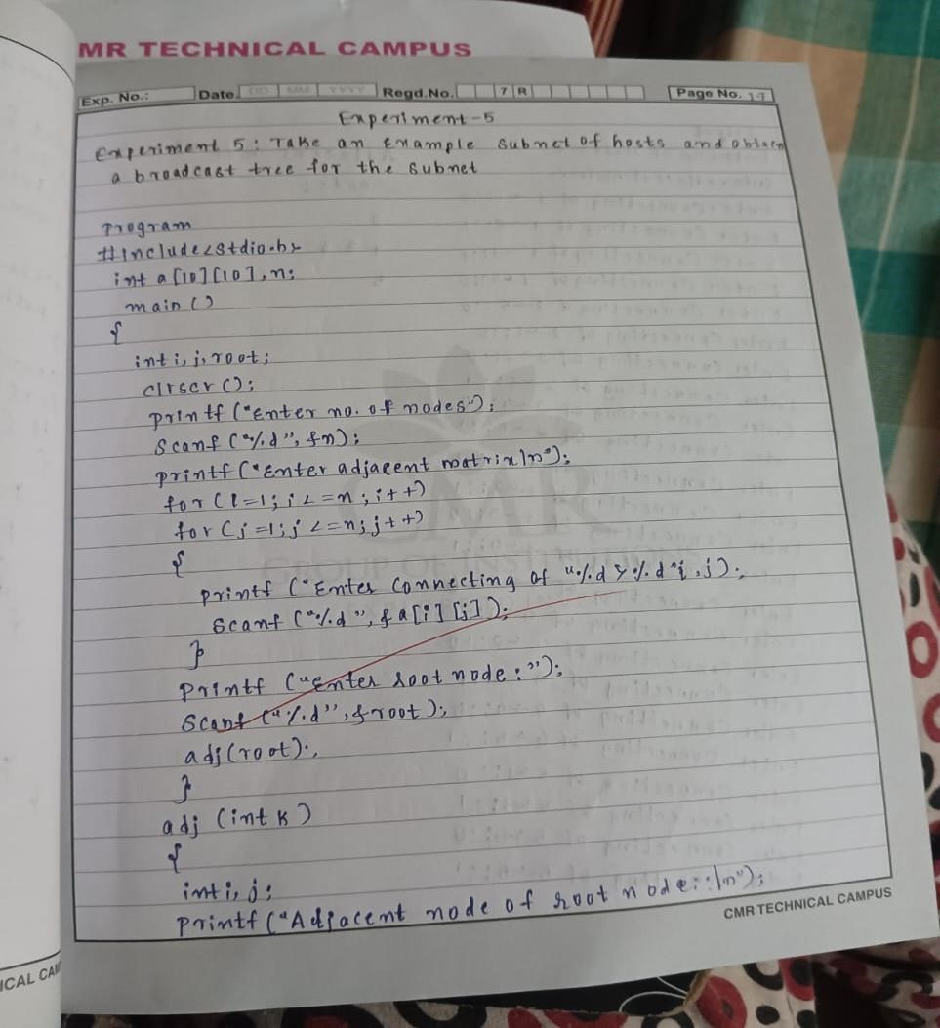

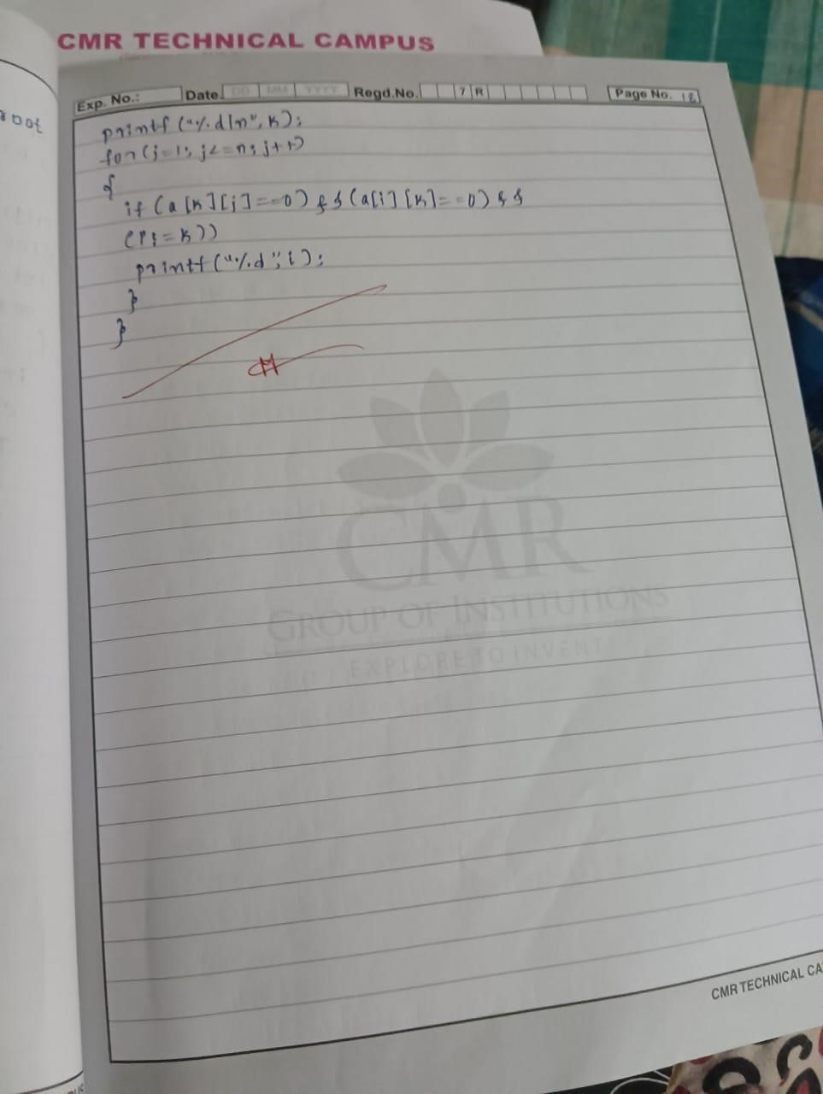

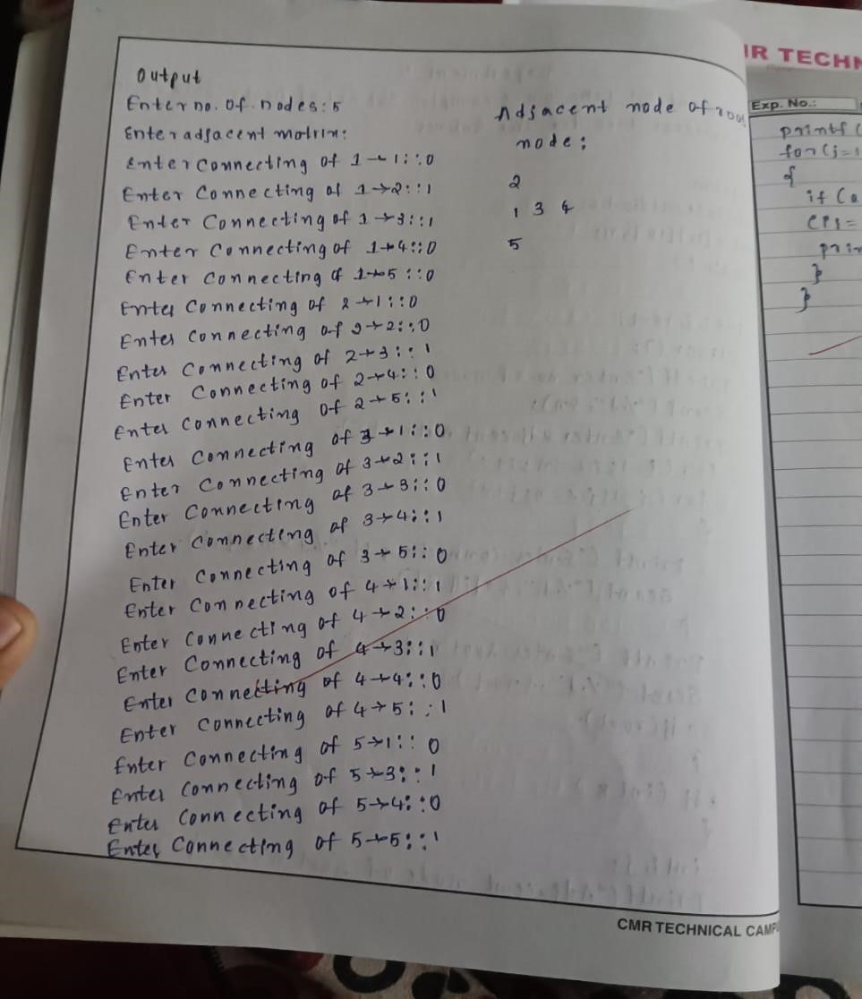

PROGRAM 6 :

Implement distance vector routing algorithm for obtaining routing tables at each node.
#include <stdio.h>
#include <stdlib.h>
#define MAX 10
// Declare the router structure typedef struct { char adj_new[MAX], adj_old[MAX]; int table_new[MAX], table_old[MAX];
} Router;
// Function to initialize a router void init_router(Router* r) { for (int i = 0; i < MAX; i++) { r->table_old[i] = r->table_new[i] = 99;
}
}
// Function to copy the old and new routing tables void copy(Router* r, int n) { for (int i = 0; i < n; i++) { r->adj_old[i] = r->adj_new[i]; r->table_old[i] = r->table_new[i];
}
}
// Function to check if the old and new tables are equal int equal(Router* r, int n) { for (int i = 0; i < n; i++) {
if (r->table_old[i] != r->table_new[i] || r->adj_new[i] != r->adj_old[i]) { return 0; // Not equal
} } return 1; // Equal
}
// Function to input the adjacency matrix and initialize the table void input(Router* r, int n, int j) {
printf("Enter 1 if the corresponding router is adjacent to router %c, else enter 99:\n", 'A' + j); for (int i = 0; i < n; i++) { if (i != j) { printf("%c ", 'A' + i);
}
}
printf("\nEnter matrix:\n"); for (int i = 0; i < n; i++) { if (i == j) r->table_new[i] = 0; // No hop count for self scanf("%d", &r->table_new[i]); r->adj_new[i] = (char)('A' + i);
} printf("\n");
}

// Function to display the routing table void display(Router* r, int n) { printf("\nDestination Router: "); for (int i = 0; i < n; i++) { printf("%c ", 'A' + i);
} printf("\nOutgoing Line: "); for (int i = 0; i < n; i++) { printf("%c ", r->adj_new[i]);
}
printf("\nHop Count: "); for (int i = 0; i < n; i++) { if (r->table_new[i] == 99) { printf("INF ");
} else { printf("%d ", r->table_new[i]);
}
}
}
// Function to build the routing table using distance vector algorithm void build(Router* r, Router* routers, int n, int j) { for (int i = 0; i < n; i++) { for (int k = 0; k < n; k++) { if (i != j && r->table_old[i] != 99) { if ((r->table_new[i] + routers[i].table_new[k]) < r->table_new[k]) { r->table_new[k] = r->table_new[i] + routers[i].table_new[k]; r->adj_new[k] = (char)('A' + i);
}
}
}
}
}
// Main function to build the table for all routers void build_table(Router* routers, int n) {
int i = 0, j = 0; while (i != n) { for (i = j; i < n; i++) { copy(&routers[i], n); build(&routers[i], routers, n, i);
} for (i = 0; i < n; i++) { if (!equal(&routers[i], n)) {
j = i; break;
}
}
}
} int main() {
int n;
Router routers[MAX];

printf("Enter the number of routers: "); scanf("%d", &n); // Initialize routers for (int i = 0; i < n; i++) { init_router(&routers[i]);
}
// Input adjacency matrices for each router for (int i = 0; i < n; i++) { input(&routers[i], n, i);
}
// Build the routing tables for all routers build_table(routers, n);
// Display the routing tables for (int i = 0; i < n; i++) { printf("\nRouter %c:\n", 'A' + i); display(&routers[i], n);
} return 0;
}

OUTPUT :
Enter the number of routers: 5
Enter 1 if the corresponding router is adjacent to router A, else enter 99:
B C D E
Enter matrix:
0 1 99 99 99

Enter 1 if the corresponding router is adjacent to router B, else enter 99:
A C D E
Enter matrix:
1 0 1 99 99

Enter 1 if the corresponding router is adjacent to router C, else enter 99:
A B D E
Enter matrix:
1 1 0 99 99

Enter 1 if the corresponding router is adjacent to router D, else enter 99:
A B C E
Enter matrix:
99 99 1 0 99

Enter 1 if the corresponding router is adjacent to router E, else enter 99:
A B C D
Enter matrix:
99 99 1 99 0

Router A:
Destination Router: A B C D E
Outgoing Line: A B C D E
Hop Count: 0 1 INF INF INF

Router B:
Destination Router: A B C D E
Outgoing Line: A B C D E
Hop Count: 1 0 1 INF INF

Router C:
Destination Router: A B C D E
Outgoing Line: A B C D E
Hop Count: 1 1 0 INF INF

Router D:
Destination Router: A B C D E
Outgoing Line: A B C D E
Hop Count: INF INF 1 0 INF

Router E:
Destination Router: A B C D E
Outgoing Line: A B C D E
Hop Count: INF INF INF INF 0

PROGRAM 7 :
Implement the data encryption and data decryption.
#include<stdio.h>

int gcd(int, int); void main() {
int p, r, n, e, d, m, c, x, q, b, s, w, i, k, a; printf("Enter any two prime numbers: "); scanf("%d", &p); printf("Enter second prime number: "); scanf("%d", &r); n = p * r; q = (p - 1) * (r - 1); printf("Calculating public key and private key...\n");
// Function to calculate gcd int gcd(int b, int s) { if (b == 0) return s; if (s == 0) return b; if (b == s) return b; if (b > s) return gcd(b - s, s); else return gcd(b, s - b);
}
// Calculate public key (e) e = 2;
while (e < q) { if (gcd(e, q) == 1) break; e++;
}
printf("Public key is (%d, %d)\n", e, n); // Calculate private key (d) k = 1; while (1) { w = (1 + k * q) % e; if (w == 0) break; k++; } d = (1 + k * q) / e; printf("Private key is (%d, %d)\n", d, n); printf("------ On SENDER SIDE ------\n"); printf("Enter the message to be transmitted: "); scanf("%d", &m); // Encrypt the message c = 1; for (i = 0; i < e; i++) { c = (c * m) % n;
}
printf("Cipher text generated is: %d\n", c); printf("------ On RECEIVER SIDE ------\n"); printf("Enter PRIVATE key: "); scanf("%d", &a); printf("Text RECEIVED is: %d\n", c);
// Decrypt the message m = 1; for (i = 0; i < a; i++) { m = (m * c) % n;
}
printf("Decrypted text is: %d\n", m);
}
OUTPUT :
Enter any two prime numbers: 61
Enter second prime number: 53
Calculating public key and private key...
Public key is (17, 3233)
Private key is (2753, 3233) ------ On SENDER SIDE ------
Enter the message to be transmitted: 65
Cipher text generated is: 2790 ------ On RECEIVER SIDE ------
Enter PRIVATE key: 2753
Text RECEIVED is: 2790
Decrypted text is: 65

